**PRACTICAL NO:02**

**AIM:** Practically implement and test the cross-wired cable and straight through cable using

clamping tool and network lab cable tester.

**APPARATUS**: (Components): RJ-45 connector, Climping Tool, Twisted pair Cable.

**THEORY:**

The Ethernet cables for connectivity in most office and home environments rely on twisted wire pairs within an overall cable - Cat 5, Cat 6 and Cat 7 all used this format. Twisting the wires together enables the currents to balance, i.e. in one wire the current is moving in one direction and in the other wire of the pair the current is going in the other, enabling the overall fields around the twisted pair to cancel.

**STRAIGHT-THROUGH WIRED CABLES STRAIGHT**-

Through refers to cables that have the pin assignments on each end of the cable. In other words, Pin 1 connector A goes to Pin 1 on connector B, Pin 2 to Pin 2, etc.

Straight-Through wired cables are most commonly used to connect a host to a client.

When we talk about cat5e patch cables, the Straight-Through wired cat5e patch cable is used to connect computers, printers, and other network client devices to the router switch or hub (the host device in this instance).

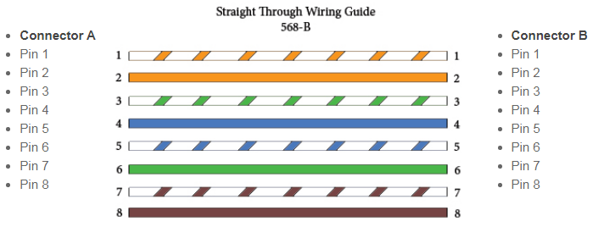

**COLOUR CODING OF STRAIGHT WIRE CABLES:**

Straight-through Cable:

           1st End                                                                         Other End

Pin1  ---   Orange Stripe                                          Pin1  ---   Orange Stripe

Pin2  ---   Orange                                                      Pin2  ---   Orange

Pin3  ---   Green Stripe                                             Pin3  ---   Green Stripe

Pin4  ---   Blue                                                            Pin4  ---   Blue

Pin5  ---   Blue Stripe                                                Pin5  ---   Blue Stripe

Pin6  ---   Green                                                         Pin6  ---   Green

Pin7  ---   Brown Stripe                                             Pin7  ---   Brown Stripe

Pin8  ---   Brown                                                         Pin8  ---   Brown

**CROSSOVER WIRED CABLES**

Crossover wired cables (commonly called crossover cables) are very much like Straight-Through cables with the exception that TX and RX lines are crossed (they are at opposite positions on either end of the cable).

Using the 568-B standard as an example below, you will see that Pin 1 on connector A goes to Pin 3 on connector B. Pin 2 on connector A goes to Pin 6 on connector B, etc.

Crossover cables are most commonly used to connect two hosts directly. Examples would be connecting a computer directly to another computer, connecting a switch directly to another switch, or connecting a router to a router. Note: While in the past, when connecting two host devices directly, a crossover cable was required. Nowadays, most devices have auto-sensing technology that detects the cable and device and crosses pairs when needed.

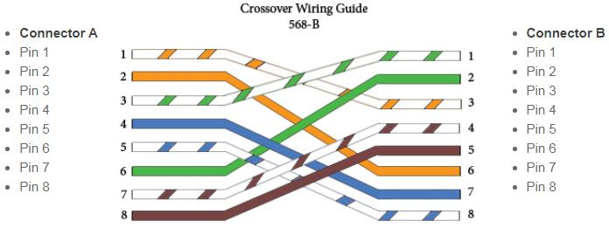

**COLOUR CODING OF CROSS WIRE CABLES:**

Cross-over Cable:

           1st End                              vice-versa                       Other End

Pin1  ---   Orange Stripe                                          Pin1  ---   Green Stripe

Pin2  ---   Orange                                                      Pin2  ---   Green

Pin3  ---   Green Stripe                                             Pin3  ---   Orange Stripe

Pin4  ---   Blue                                                            Pin4  ---   Blue

Pin5  ---   Blue Stripe                                                Pin5  ---   Blue Stripe

Pin6  ---   Green                                                         Pin6  ---   Orange

Pin7  ---   Brown Stripe                                             Pin7  ---   Brown Stripe

Pin8  ---   Brown                                                         Pin8  ---   Brown

**HOW TO MAKE AN ETHERNET CABLE**

1. Cut into the plastic sheath about 1 inch (2.5 cm) from the end of the cut cable. The crimping tool has a razor blade that will do the trick with practice.

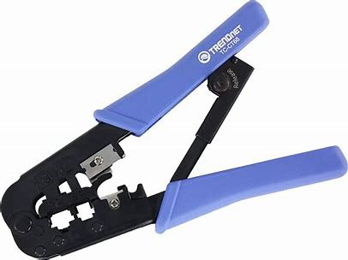 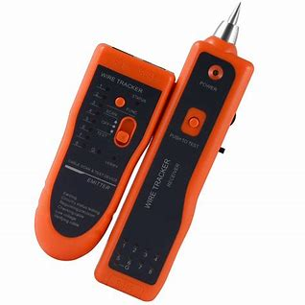**TESTER**

**CRIMPING TOOL**

2. Unwind and pair the similar colors.

3. Pinch the wires between your fingers and straighten them out as shown. The color order is important to get correct.

4. Use scissors to make a straight cut across the 8 wires to shorten them to 1/2 Inch (1.3 cm) from the cut sleeve to the end of the wires.

5. Carefully push all 8 unstripped colored wires into the connector. Note the position of the blue plastic sleeve. Also note how the wires go all the way to the end.

6. A view from the top. All the wires are all the way in. There are no short wires.

7. CRIMPING THE CABLE: carefully place the connector into the Ethernet Crimper and cinch down on the handles tightly. The copper splicing tabs on the connector will pierce into each of the eight wires. There is also a locking tab that holds the blue plastic sleeve in place for a tight compression fit. When you remove the cable from the crimper, that end is ready to use.

8. For a standard "Straight Through" cable, repeat all steps and wire color order on the other end of cable. For a cross-over cable, the other end will have a different color order as shown by the crossover picture above.

**DIFFERENCE BETWEEN STRAIGHT THROUGH CABLES AND CROSSOVER CABLES:**

|  |  |
| --- | --- |
| **STRAIGHT WIRE CABLE** | **CROSS WIRED CABLE** |
| Straight-through cable is a type of CAT5 with RJ-45 connectors at each end, and each has the same pin out. | A Crossover cable is a type of CAT where one end is T568A configuration, and the other end as T568B Configuration. |
| It is one of the most commonly used cable formats for network cables. | It is used only for certain applications. |
| You can also connect it to the router’sLAN port to a switch/hub’s uplink port. | You can connect it to a router’s LAN port to a switch or hub’s regular port. |
| Straight through cable connects a computer with a cable or DSL modem’s LAN port. | Crossover cable connects with a router’s LAN port with switch/hub normal port. |
| You should use straight-through cable when you want to connect two devices of different types. | You should use a crossover cable when you want to connect two devices of the same type. |